Google Posting
SOP | Manipal Hospitals
1. GBP Posting SOP Guidelines:
Create regular Google Business Profile posts to share updates, offers, events, services, and important business information. Use high-quality images, clear descriptions, relevant keywords, and accurate details. Keep posts engaging, avoid excessive promotional content, and ensure all content follows Google Business Profile policies. Update posts regularly to improve customer engagement and visibility.
1.1 Content Guidelines for Posts:
Create clear, relevant, and engaging content that highlights business updates, services, offers, or events. Use accurate information, appropriate keywords, and high-quality images. Avoid misleading claims, excessive promotional language, spam content, or prohibited information. Ensure posts follow Google Business Profile policies and maintain a consistent posting schedule
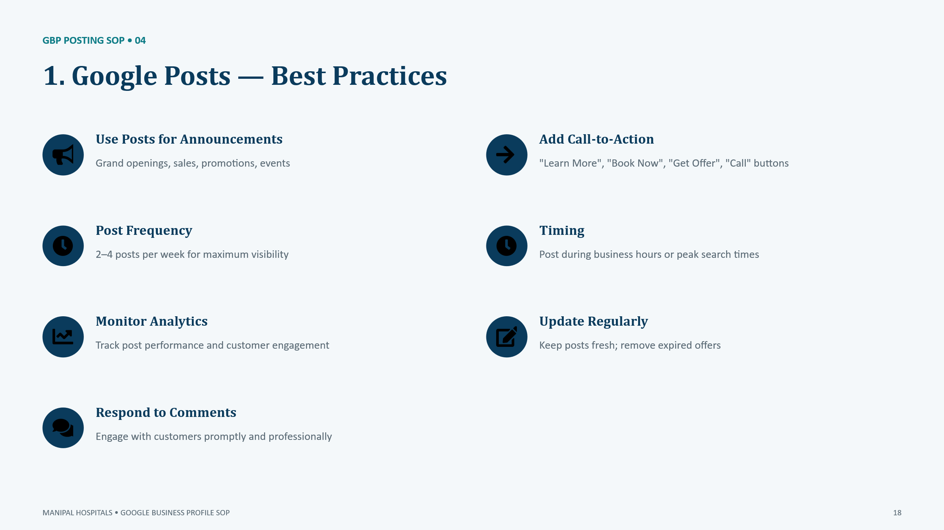
Google Guideline: https://support.google.com/business/answer/7213077?hl
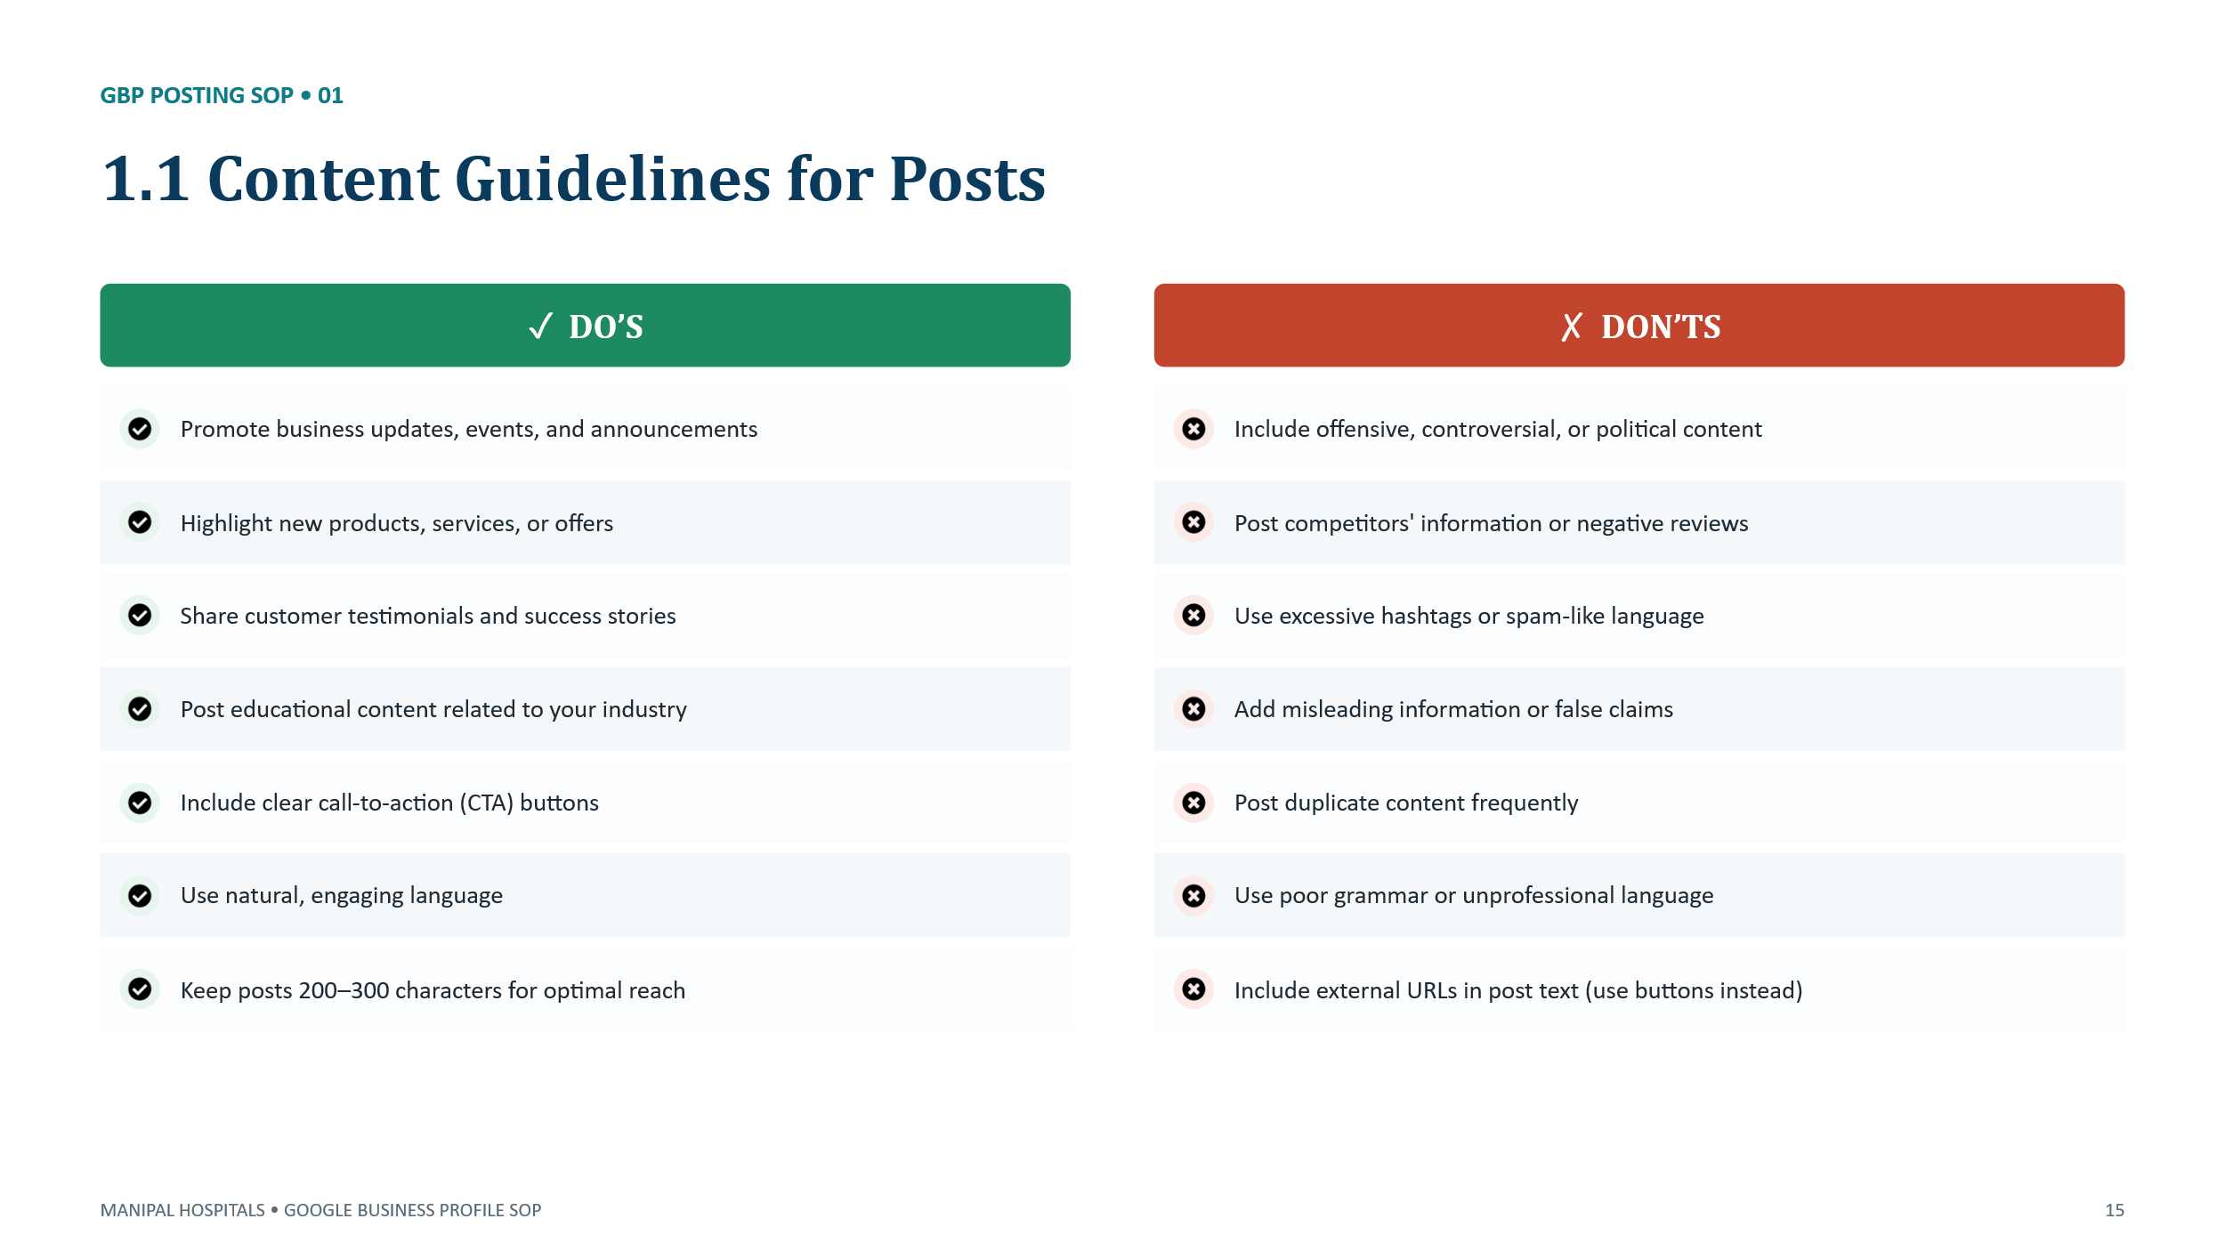
Google Guideline: https://support.google.com/business/answer/7342169
Google Guideline: https://support.google.com/business/answer/7213077
1.2 Image & Banner Guidelines
Use high-quality, relevant, and original images that represent the business, products, services, and customer experience. Ensure images are clear, properly sized, and updated regularly. Avoid stock images, misleading visuals, excessive text, logos, or promotional banners that do not follow Google Business Profile guidelines.
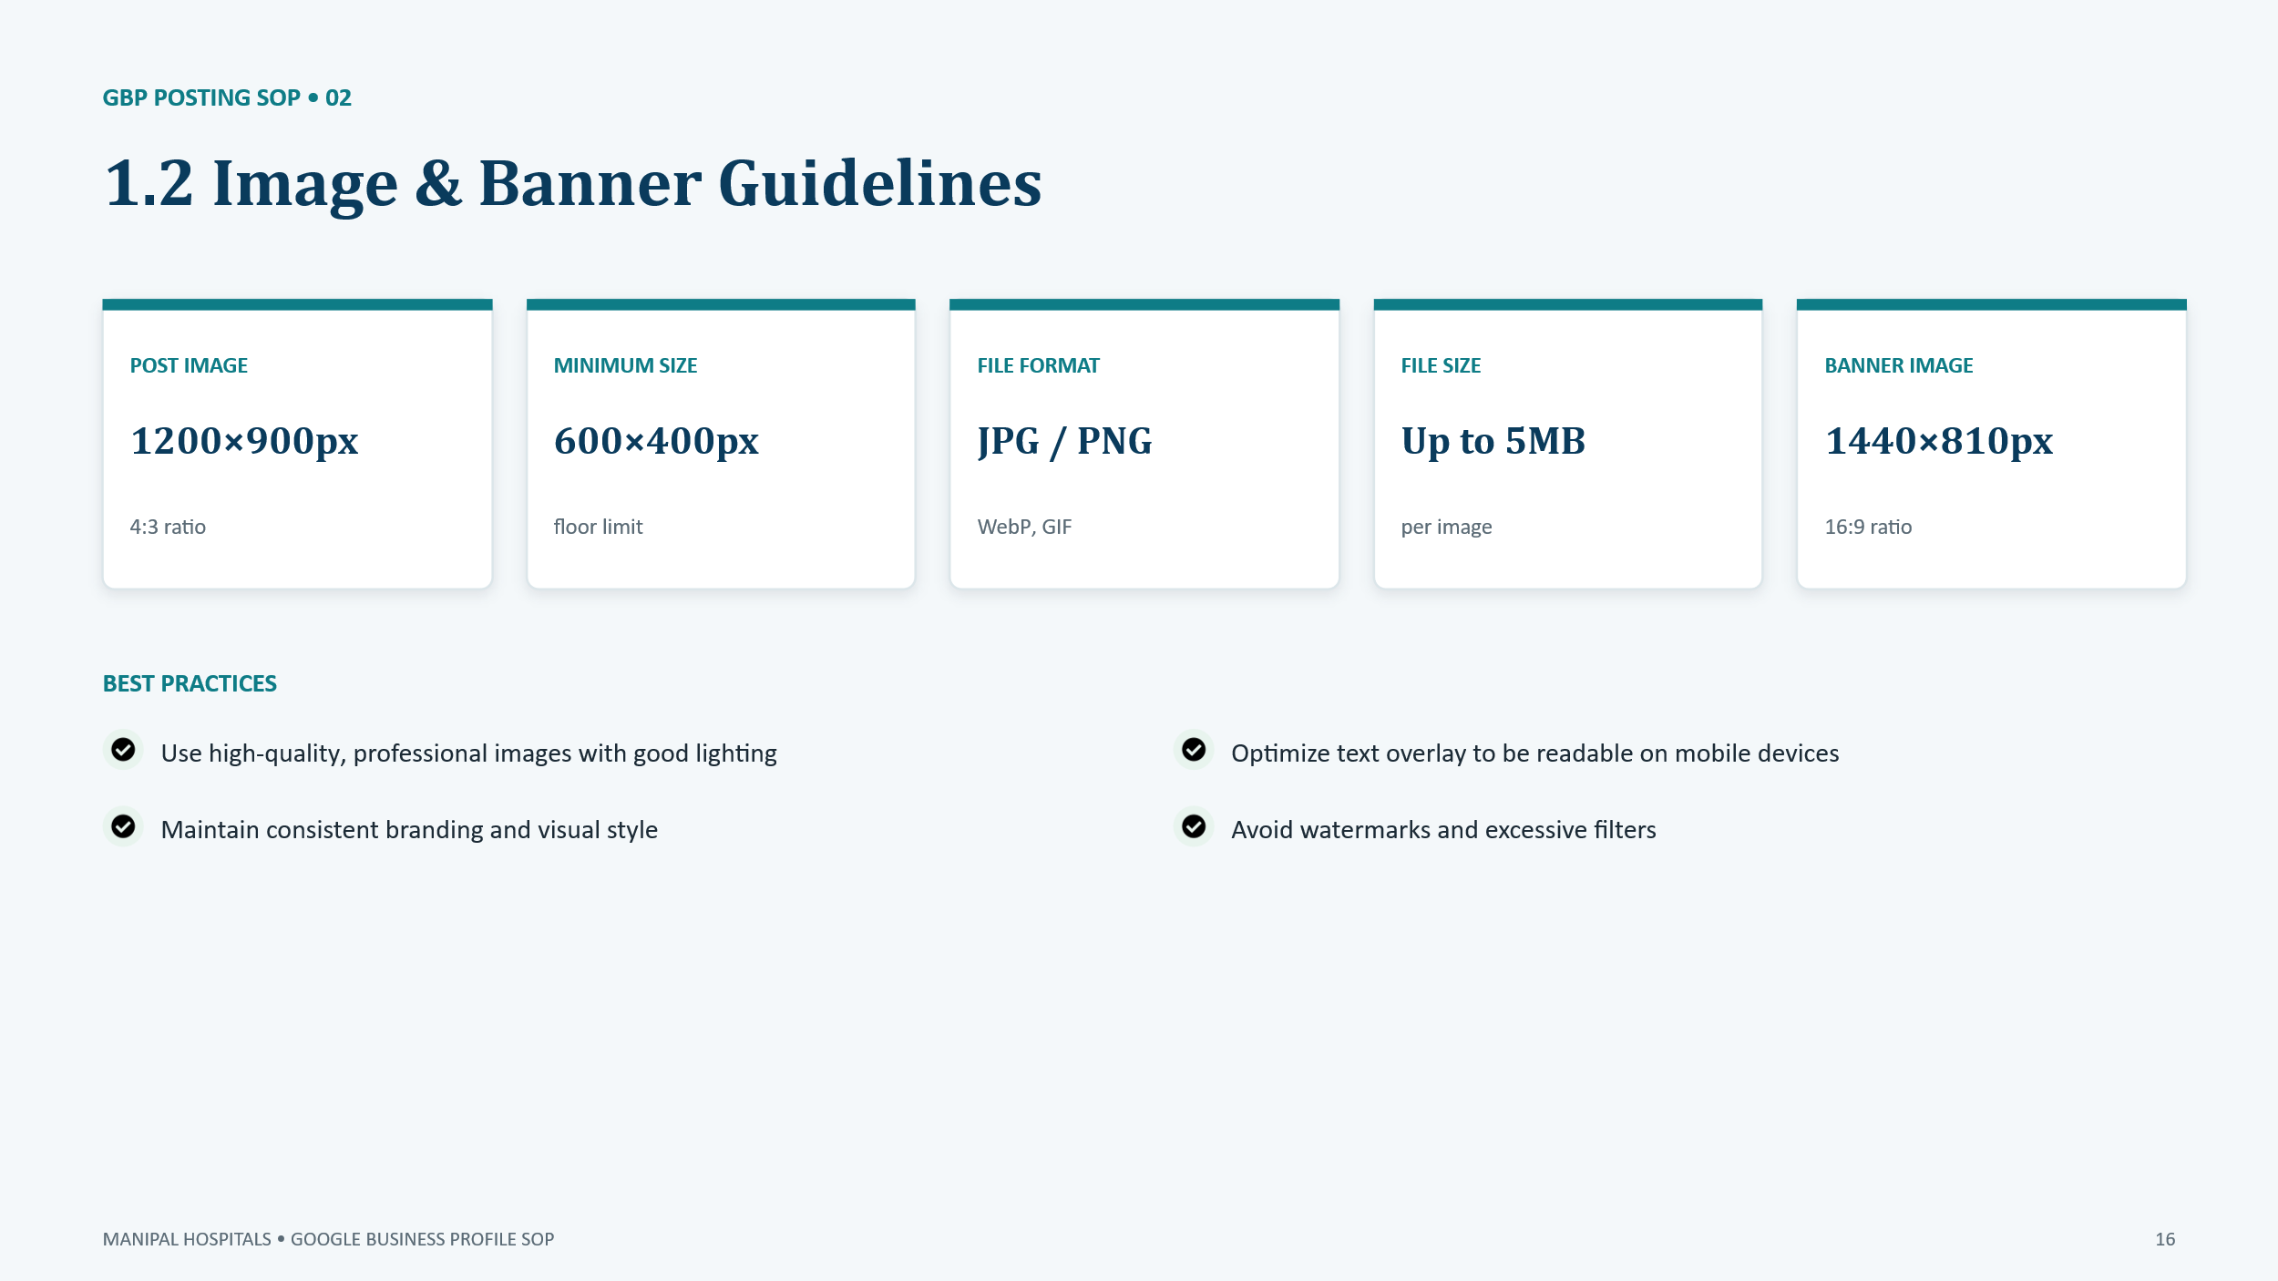
Google Guideline: https://support.google.com/business/answer/6103862
1.3 Photo & Video Guidelines
Upload high-quality, original photos and videos that accurately represent the business, products, services, and customer experience. Use clear visuals, proper lighting, and relevant content. Keep media updated regularly and avoid stock images, misleading content, excessive text, watermarks, or unrelated visuals.
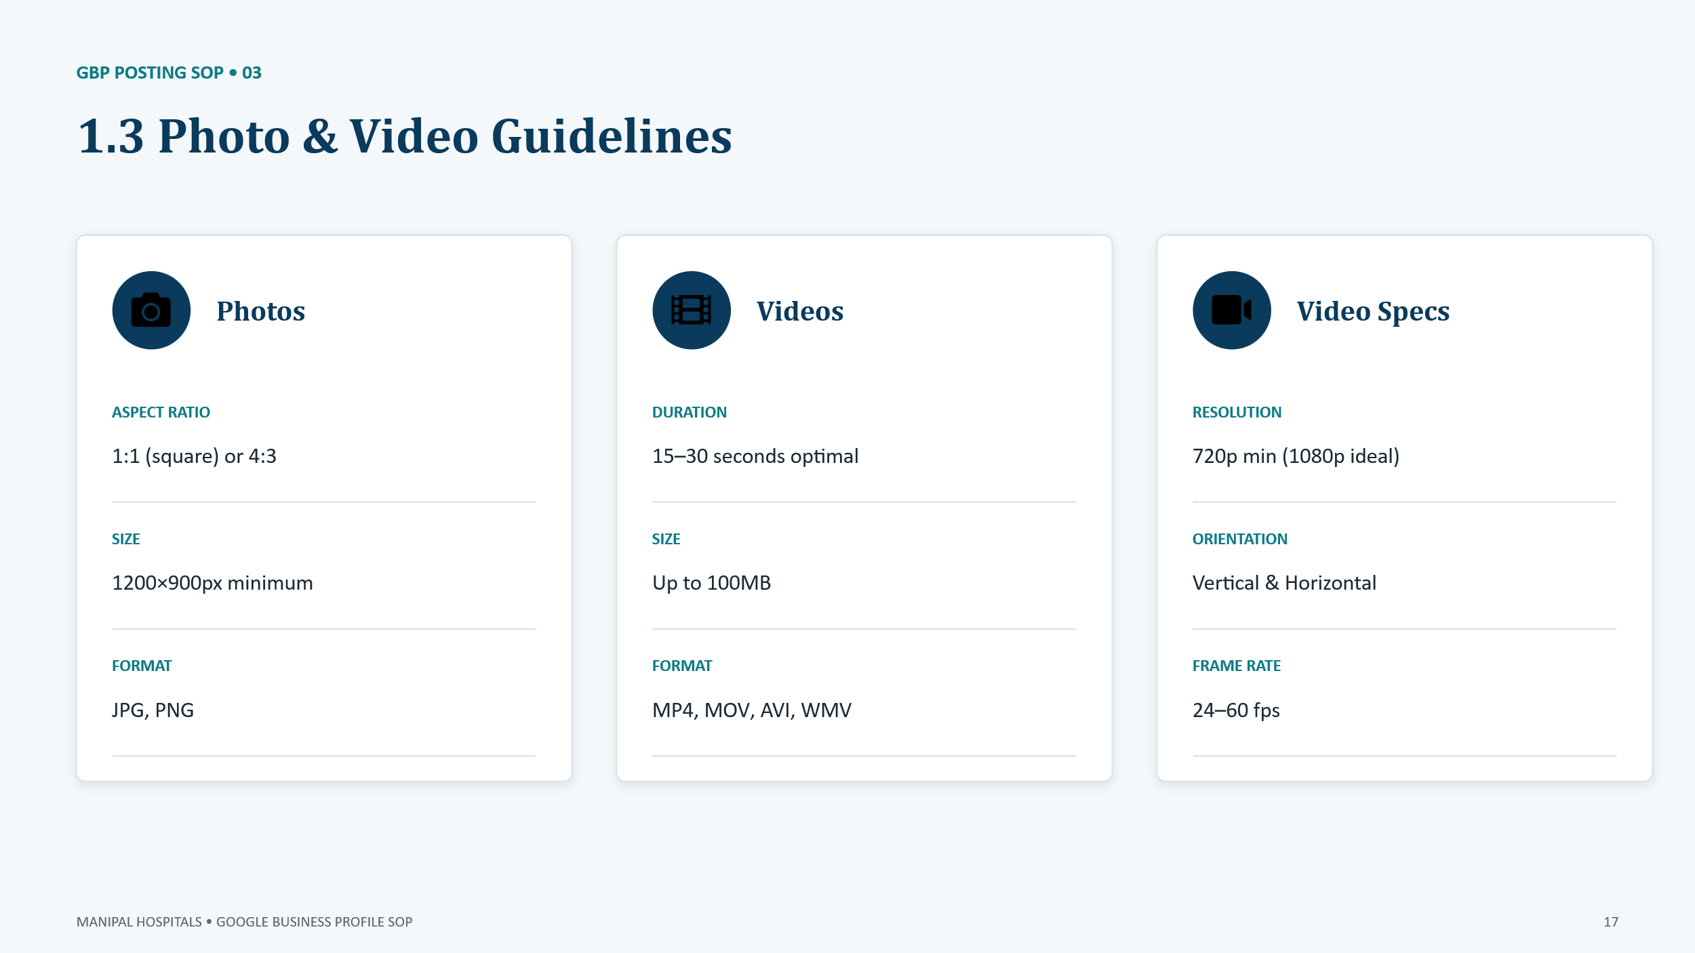
Google Guideline: https://support.google.com/business/answer/6103862

